AWS ADVANCED PROJECT-5

**Scheduling basic job in Jenkins**

ARAVIND G KUMAR

**Introduction:**

**Jenkins** is a free and open-source automation server. It helps automate the parts of software development related to building, testing, and deploying, facilitating continuous integration and continuous delivery. It is a server-based system that runs in servlet containers such as Apache Tomcat.

* Create a Jenkins repository in git hub.
* Create a new repo named Jenkins.
* Now create a new file named HelloWorld.java.
* Copy pastes the java script for hello world.

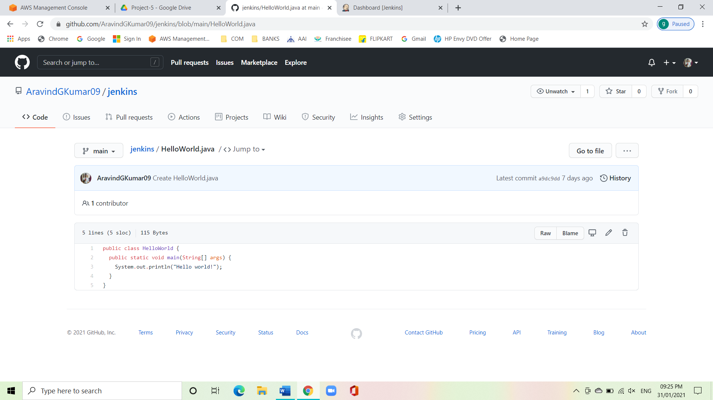

* Create a freestyle project.
* Under dashboard, select new item.

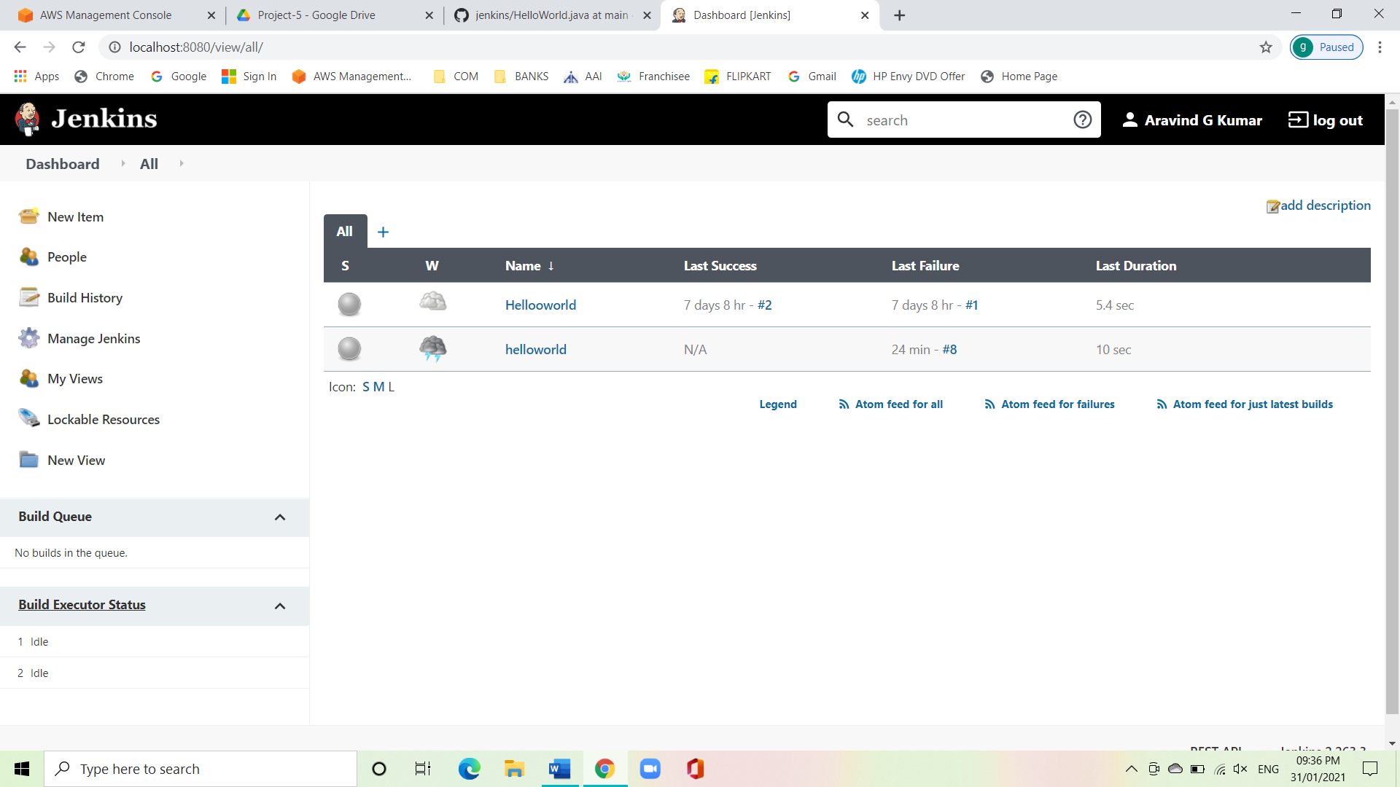

* Enter the item name and select freestyle project.

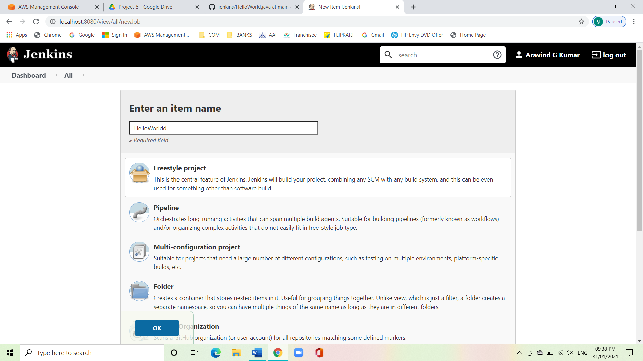

* Give a description and move down to source code management.
* Under SCM click on git and paste the Jenkins repository URL.
* Click on advanced.
* Give the name as origin and refspec as the following code:

+ref/pull/*:refs/remotes/origin/pr/*

* Clear the branch specifier.

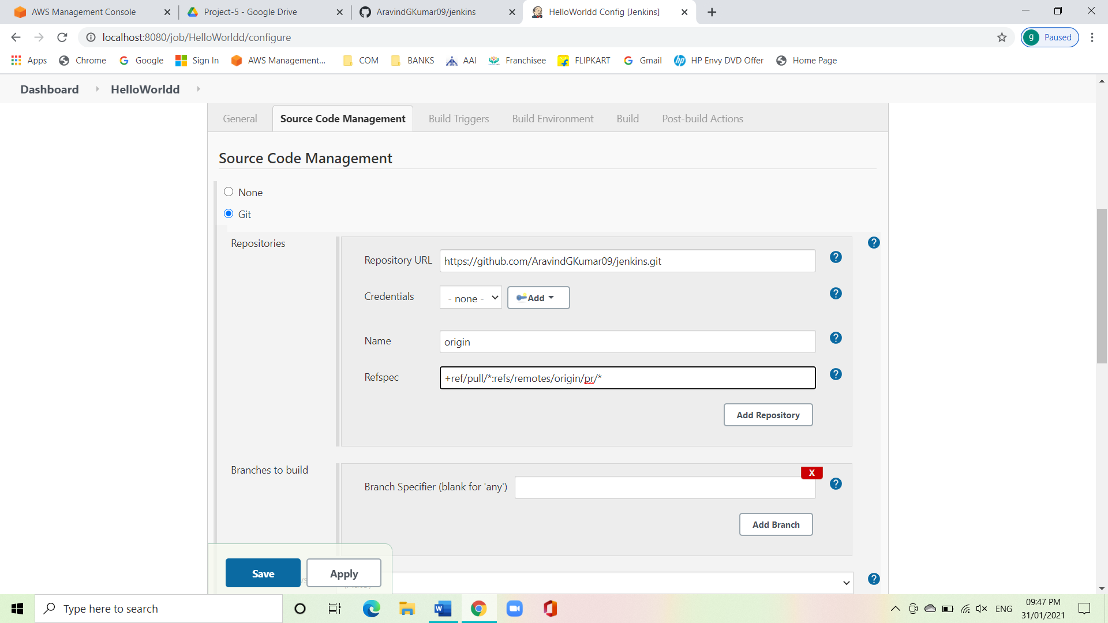

* Scroll down to build and click on execute windows batch command.
* Now give the following command:

Javac HelloWorld.java

Java HelloWorld

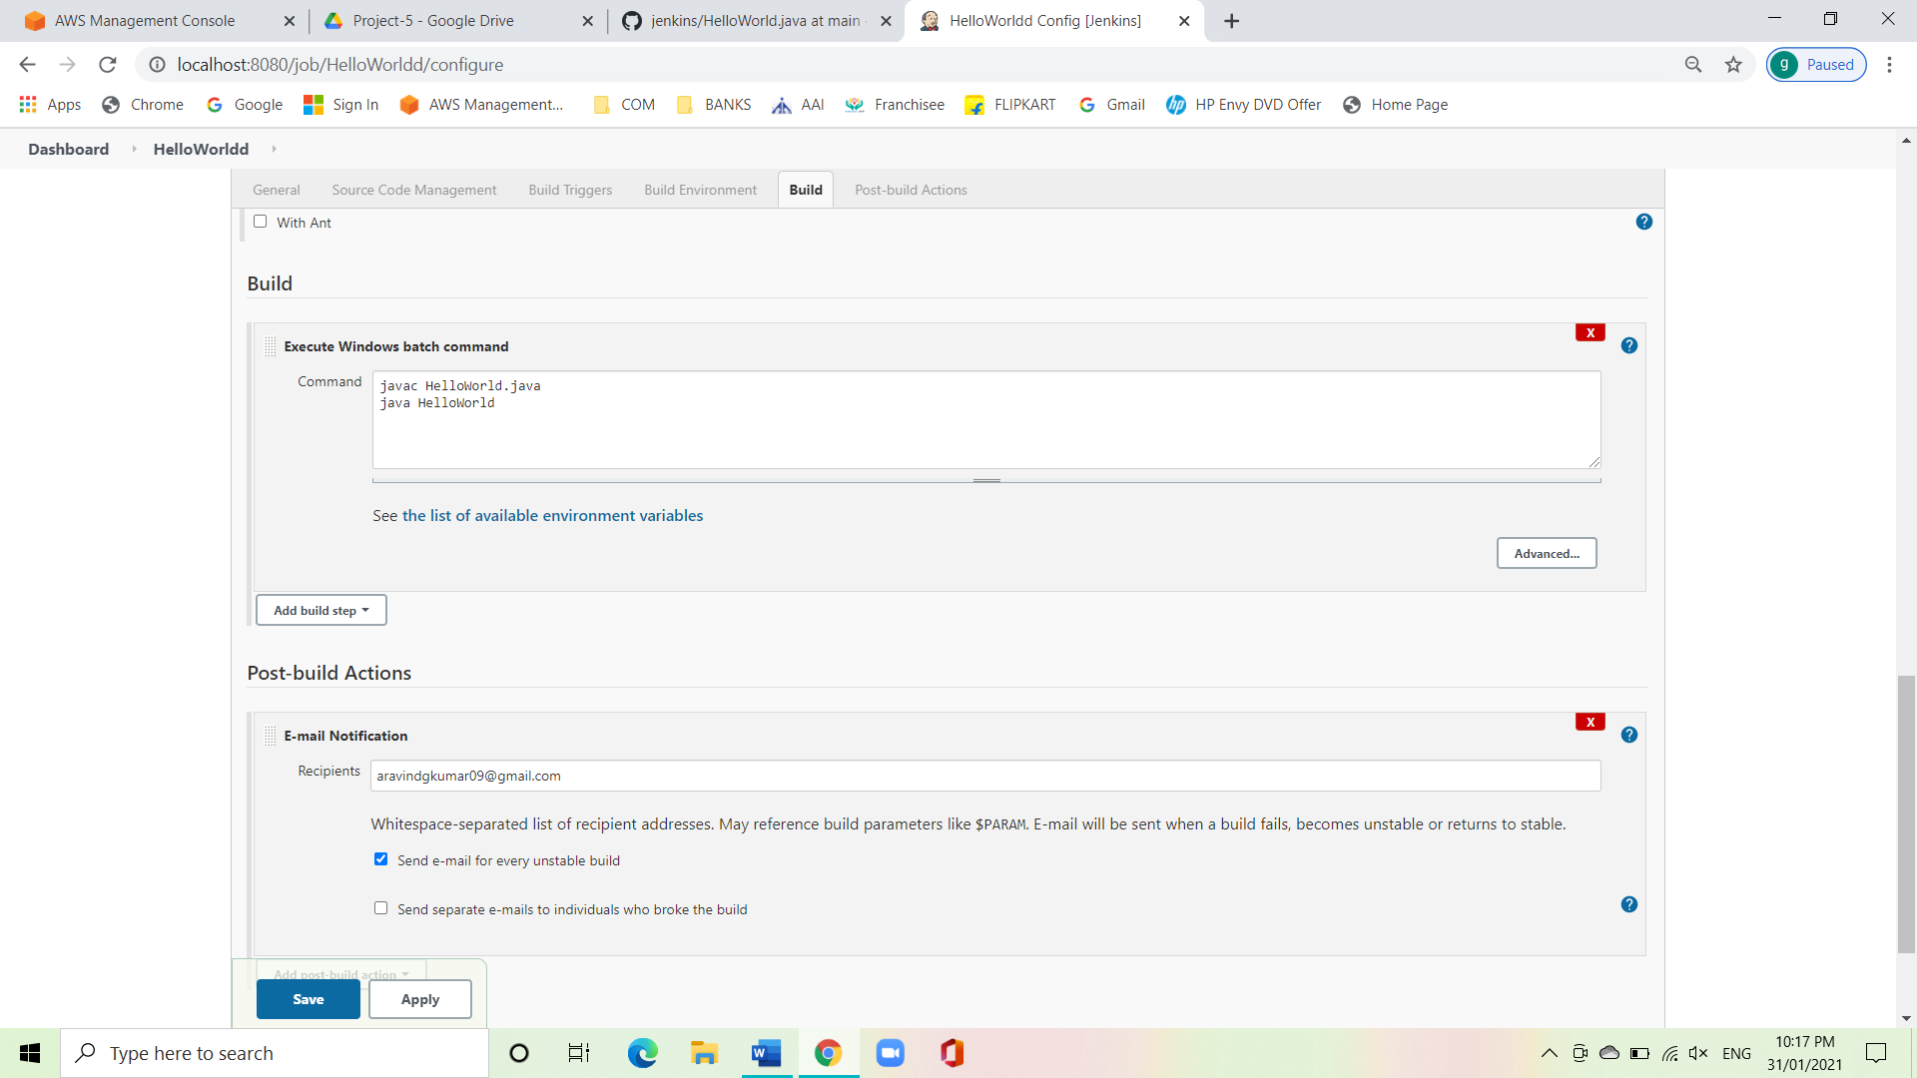

* Click on apply and save.
* Now click on build now.
* Click on the build that was created now and span into the console output and can see the success message.

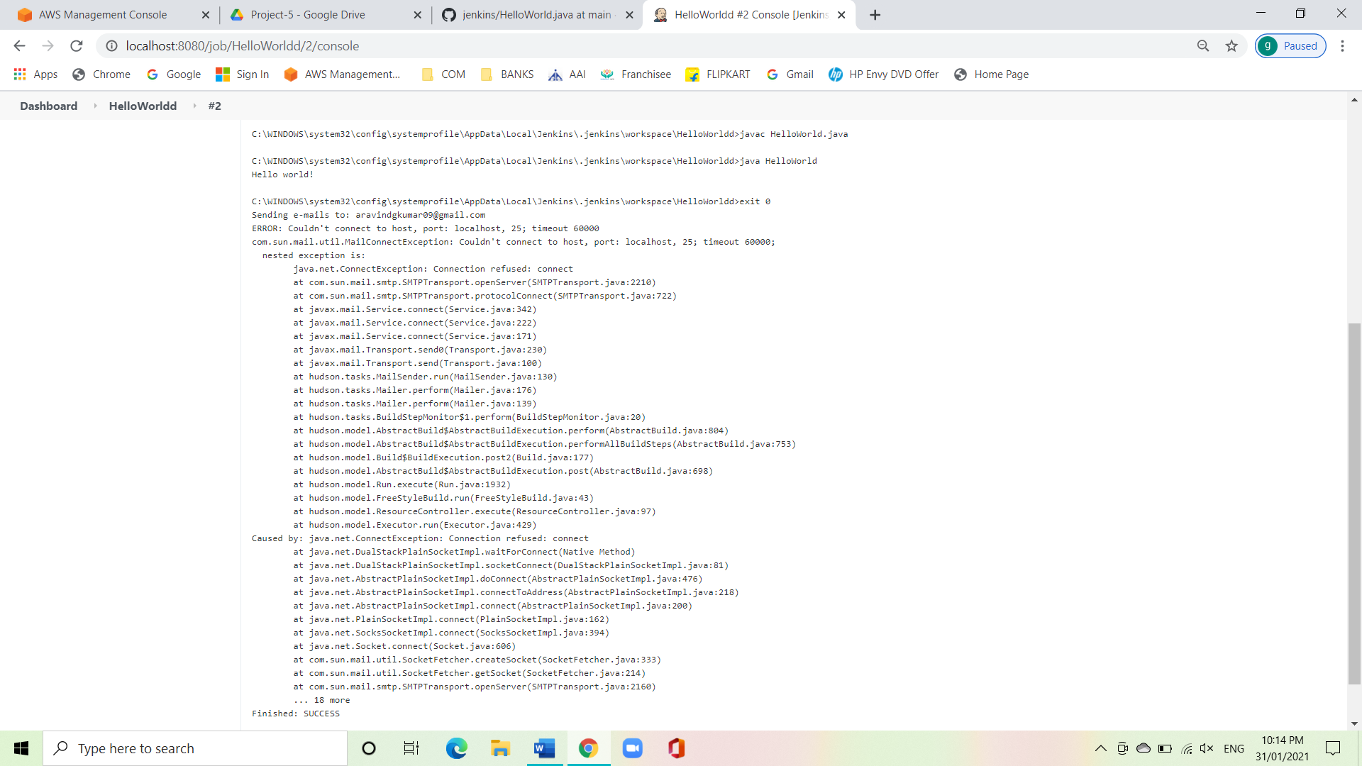

**Conclusion:**

We have successfully created a local job in Jenkins using git.